.NET ASSIGNMENT QUESTIONS (BASIC TRAINING)

Session 1: Understanding .Net eco system & Development environment and C# programming Fundamentals (~4 hrs)
Classroom-Assignments

Assignment 1:
Write a console program that takes a meter serial number as input and prints it.
Sample Input:
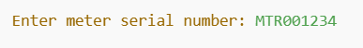
Expected Output:
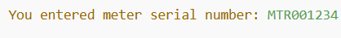

Assignment 2:
Create a program that checks if a meter's reading is within a valid range (100–200).
Sample Input :
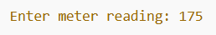
Expected Output :
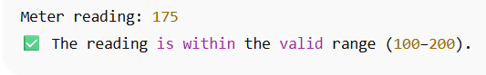

Assignment 3:
Create a student grade evaluator that takes scores for five subjects, calculates average, assigns a grade, and flags failing marks using loops and conditional logic.

Sample Input :
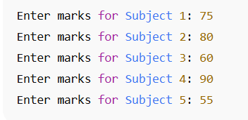
Expected Output :
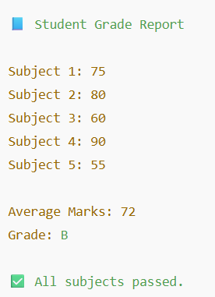

Assignment 4:
Develop a number analysis tool that accepts a list of integers from the user, then calculates and displays the sum, average, highest, and lowest numbers using loops and arithmetic operators.
Sample Input:
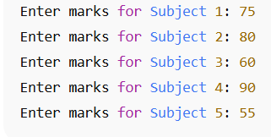

Expected Output :
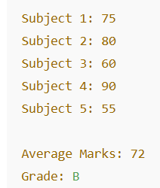

Stretch Goals
Task 1: Meter Serial Number Input & Print
Original Task:
Take a meter serial number as input and print it.
Stretch Goals:
- Input Validation:
  - Ensure the serial number follows a specific format like MTR-YYYY-XXX (e.g., MTR-2025-A1B2) using Regex.
- Duplication Check:
  - Allow the user to enter multiple serial numbers and store them in a list.
  - Prevent duplicate entries and show a warning if one is repeated.
- File I/O:
  - Save all entered serial numbers into a text file (serials.txt), one per line.
- Checksum Validation:
  - Add logic to validate a simple checksum (e.g., last 2 digits must equal the sum of the digits in the year).

Session 2: OOPS fundamentals and Advanced (~4 hrs)
Classroom-Assignments

Assignment 1:
Classes & Objects – Student Management System
Objective:
Create and use classes with properties, constructors, and methods.
Tasks:
- Create a class Student with the following:
  - Properties: Name, RollNumber, Course, Marks (out of 100)
  - Method: DisplayDetails () to print student details
- In Main ():
  - Create at least 3 objects of Student
  - Use a constructor to assign values
  - Call the DisplayDetails () method for each student
Output Format:
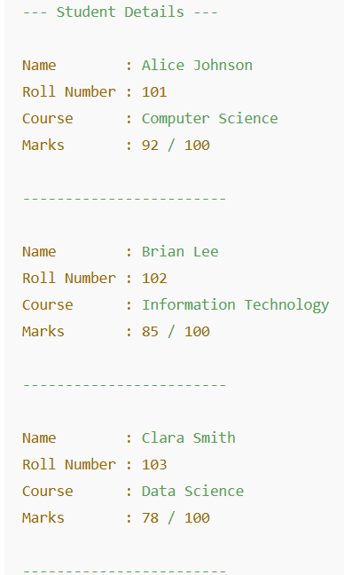

Assignment 2:
Inheritance – Employee Hierarchy
Objective:
Apply inheritance and constructor chaining in C#.
Tasks:
- Create a base class Employee:
  - Properties: EmpID, Name, BasicSalary
  - Method: Display ()
- Create two subclasses:
  - Manager → additional property: Bonus
  - Developer → additional property: ProjectName
- Override Display() in both subclasses.
- In Main():
  - Create objects of Manager and Developer and display full info.
Output Format:
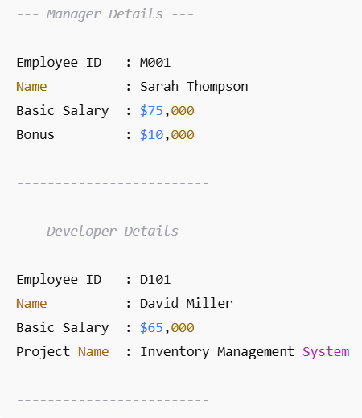

Assignment 3:
Polymorphism – Shape Calculator
Objective:
Demonstrate method overriding and runtime polymorphism.
Tasks:
- Create an abstract class Shape with:
  - Method: CalculateArea () (abstract)
- Create subclasses:
  - Circle → property: Radius
  - Rectangle → properties: Length, Breadth
- Override CalculateArea () in both.
- In Main ():
  - Use a Shape reference to call the method for each derived class (polymorphism).
  - Output area values with shape name
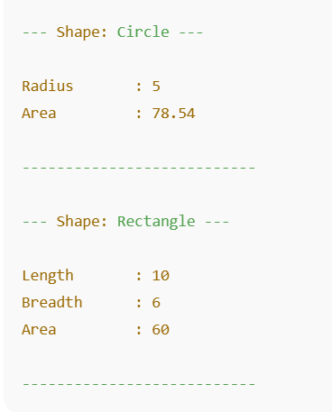
Output Format:

Assignment 4:
Interfaces – Payment Gateway System
Objective:
Use interfaces to enforce common functionality across unrelated classes.
Tasks:
- Create an interface IPayment with:
  - Methods: Pay (), Refund ()
- Implement it in 2 classes:
  - CreditCardPayment
  - UPIPayment
- Each class should:
  - Store relevant details (e.g., card number, UPI ID)
  - Implement the methods with sample output
- In Main ():
  - Create a list of IPayment objects and call Pay ()/Refund () using a loop.
Output Format:
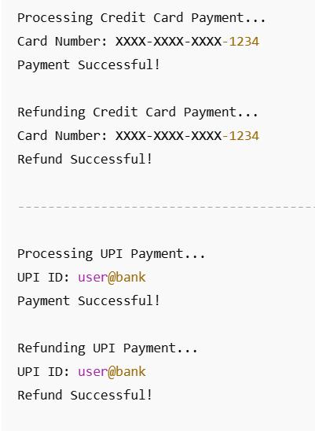

Stretch Goal:
OOP Integration Project – Library System
Objective:
Combine all OOP concepts in a real-world example.
Tasks:
- Create:
  - Base class LibraryItem with Title, ID, IsAvailable
  - Subclasses: Book, Magazine
- Use an interface IBorrowable with methods: Borrow(), ReturnItem()
- Implement the interface in Book only.
- Use polymorphism to loop through all items and perform borrow/return actions based on type
Output Format:
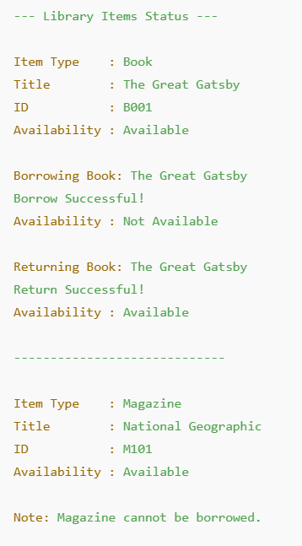

Session 3: C# data structures and LINQ(~2 hrs)

Assignment 1:

Student Grades – Arrays, Lists & LINQ
Objective: Use arrays, lists, and LINQ to process student data.
Tasks:
- Create a Student class with:
  - Properties: Name, RollNumber, Marks (int[] of 5 subjects)
- In Main ():
  - Create a List<Student> and add at least 5 students with marks.
  - For each student:
    - Calculate total and average marks using LINQ.
    - Display highest and lowest scoring student using LINQ.
Output Format: 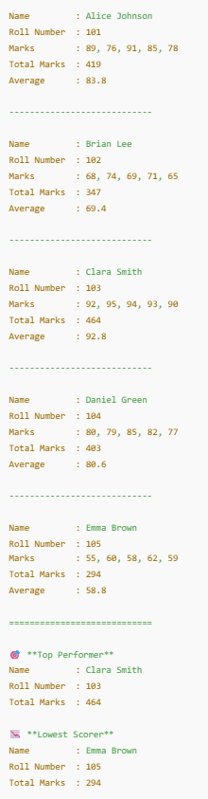

Assignment2:
Library Management – Dictionary, HashSet, LinkedList
Objective: Use dictionaries and collections to manage book inventory.
Tasks:
- Use a Dictionary<int, string> to store book ID and title.
- Use a HashSet<string> to track issued book titles (to prevent duplicates).
- Use LinkedList<string> to manage the borrow queue.

Output Format:
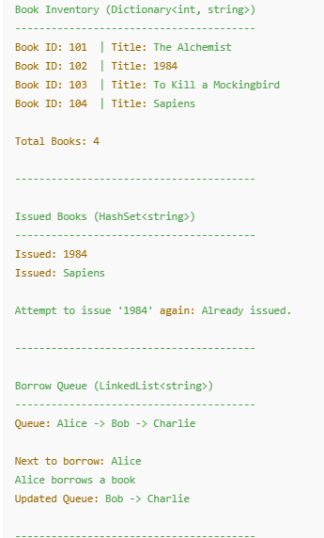

Assignment3:
LINQ – Advanced Student Analytics
Objective: Perform advanced LINQ queries on student data.
Tasks:
- Create a Student class:
  - Name, RollNumber, Marks (Dictionary<string, int> → subject, mark)
- In Main():
  - Add 5 students with marks for 3 subjects.
  - Use LINQ to:
    - a) Find students scoring above 85 in all subjects.
    - b) Find the average mark per subject across all students.
    - c) Get the top scorer per subject.
Output Format:
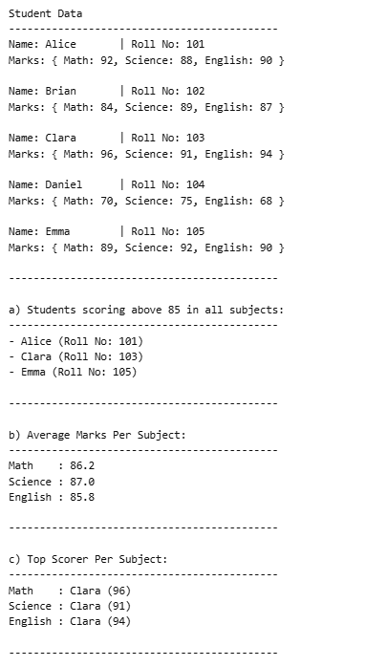

Assignment 4:
LINQ – Employee Department Join
Objective: Use join, group join, and aggregate queries.
Tasks:
- Create:
  - Employee class: ID, Name, DepartmentID, Salary
  - Department class: ID, DeptName
- In Main():
  - Add sample employees and departments.
  - Use LINQ to:
    - a) Join employees with their department names.
    - b) Group employees by department and calculate:
      - Average salary
      - Count of employees per department
    - c) Find department(s) with the highest average salary.
Output format:
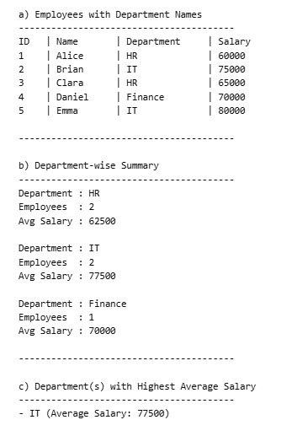

Stretch Goal:
LINQ – Product Sales Report
Objective: Combine filtering, ordering, and grouping with LINQ.
Tasks:
- Create a ProductSale class:
  - ProductName, Category, UnitsSold, UnitPrice
- In Main():
  - Add at least 10 product sales records across 3 categories.
- Use LINQ to:
  - a) Group by category and find:
    - Total revenue per category
    - Best-selling product per category
  - b) List top 3 products by total revenue.
  - c) Filter products with revenue > 1000 and order by revenue descending.
Output Format:
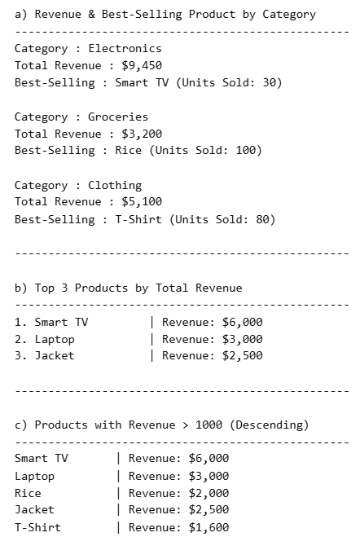

Session 4: .Net working with database(~ 2HRS)
Classroom-assignment

Assignment 1:
- Create a SmartMeter class with properties:
- Id (int)
- SerialNumber (string)
- Reading (int)
- Location (string)
- Timestamp (DateTime)
- Define an interface ISmartMeterRepository with methods like:
- IEnumerable<SmartMeter> GetAll()
- SmartMeter GetById(int id)
- IEnumerable<SmartMeter> GetByLocation(string location)
- void Add(SmartMeter meter)
- void Update(SmartMeter meter)
- void Delete (int id)
- Implement the interface in a class SmartMeterRepository:
- Use an in-memory List<SmartMeter> as the data store.
- Use LINQ queries for filtering, retrieving, and updating.
- In the Main () method:
- Add sample records.
- Demonstrate each repository operation (add, update, delete, filter by location, get all, etc.)
- Display results to the console.

Output Format:
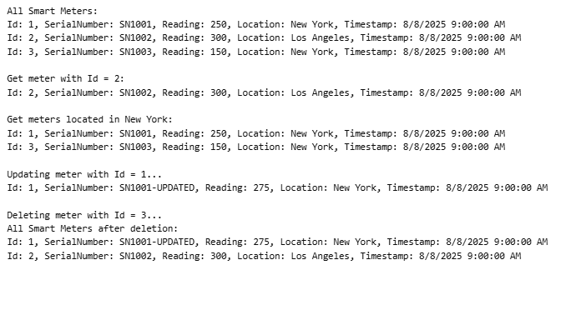

Session 5: Building REST API with data persistence and Advanced MVC (~4 hrs)
Classroom-Assignments

Assignment 1:
Basic MVC Web App with CRUD
Objective: Build a simple MVC application to manage a list of products.
Tasks:
- Create a Product model with properties: Id, Name, Description, Price.
- Create a ProductController with actions for:
  - Listing all products (Index)
  - Viewing product details (Details)
  - Creating a new product (Create)
  - Editing an existing product (Edit)
  - Deleting a product (Delete)
- Use in-memory data storage (e.g., a static list) to perform CRUD operations.
- Implement basic routing so URLs follow RESTful conventions.
Output format:
(e.g. for List All Products — /Products or /Products/Index)
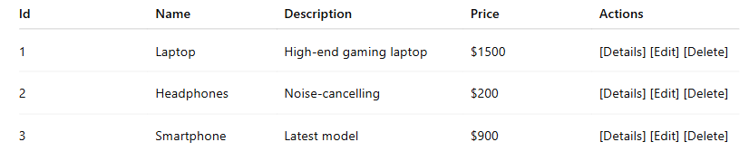

Assignment 2: RESTful API for Employee Management
Objective: Develop a REST API for employee data.
Tasks:
- Create an Employee model with Id, Name, Department, Salary.
- Implement an EmployeeController with REST endpoints:
  - GET /api/employees — List all employees
  - GET /api/employees/{id} — Get employee by ID
  - POST /api/employees — Add a new employee
  - PUT /api/employees/{id} — Update employee info
  - DELETE /api/employees/{id} — Delete an employee
- Use routing attributes to configure routes.
- Return appropriate HTTP status codes.
- Use a simple in-memory list for storage.
Output Format:
(e.g., for GET /api/employees)
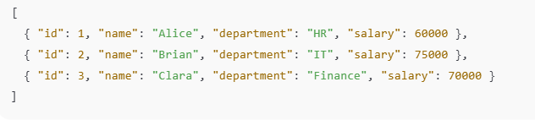

Stretch Goal:
Implement Filters in MVC
Objective: Use filters for authentication and logging.
Tasks:
- Create a custom authorization filter that restricts access to certain controller actions.
- Implement a logging filter that logs action execution time and details.
- Apply filters globally and on specific controller actions.
- Demonstrate filters working in an MVC app with at least two controllers.
Output Format:
(e.g for Authorization Filter)
